A1.
Prove by mathematical induction.

A2.
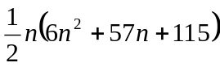 , 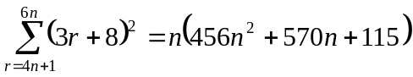 , 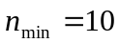

A3.
(i) 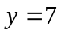 , 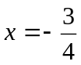 and 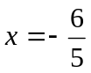.
(ii) The function is decreasing.

A4.
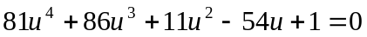 , 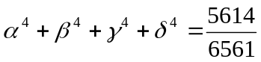 , 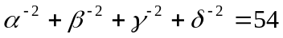.

B1.
,

B2.
(ii) 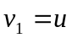
(iii) 